Definition of: DBMS
DataBase Management System Software that controls the organization, storage, retrieval, security and integrity of data in a database. It accepts requests from the application and instructs the operating system to transfer the appropriate data. The major DBMS vendors are Oracle, IBM, Microsoft.

Hierarchical, Network & Relational
Information systems are made up of related files: customers and orders, vendors and purchases, etc. A key DBMS feature is its ability to manage these relationships.
Hierarchical databases link records like an organization chart. A record type can be owned by only one owner. In the following example, orders are owned by only one customer. Hierarchical structures were widely used with early mainframe systems; however, they are often restrictive in linking real-world structures.
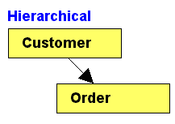
In network databases, a record type can have multiple owners. In the example below, orders are owned by both customers and products, reflecting their natural relationship in business.

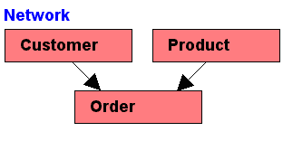

Relational databases do not link records together physically, but the design of the records must provide a common field, such as account number, to allow for matching. Often, the fields used for matching are indexed in order to speed up the process.

Data Modeling Objects
The three types of data objects--entities, attributes, and relationships--are the basic building blocks of modeling:
- Entities are persons, places, or things about which an organization wishes to save information. Employees, States, Orders, and Time Sheets are examples of entities.
- Attributes are the properties of entities. Attribute examples include Color, Employment Date, Name, and Social Security Number.
- Relationships are verbs that describe how entities relate to each other; for example: 'Customers Buy Products,' 'Employees File Time Sheets,' 'Salespeople Place Orders.' A sentence in this entity-relationship-entity construct is called a "relationship entity pair," which is a fashionable mechanism for representing relationships. Relationship entity pairs are bidirectional. Therefore, 'Customers Buy Products' is the same as 'Products are Bought by Customers.'

Definition: An entity-relationship (ER) diagram is a specialized graphic that illustrates the interrelationships between entities in a database. ER diagrams often use symbols to represent three different types of information. Boxes are commonly used to represent entities. Diamonds are normally used to represent relationships and ovals are used to represent attributes.
- rectangles representing entity sets.
- ellipses representing attributes.
- diamonds representing relationship sets.
- lines linking attributes to entity sets and entity sets to relationship sets.
Entity
Attribute

Relationship

